Lab # 8: SQL: DCL
Subject: Database Systems
Course: BESE15 B
Date: 23rd November, 10

- Submissions have to be done by the end of lab.
- Submissions in groups of two are allowed.

TASK:

Consider the following scenario. Create an ERD for the scenario presented, and based on that ERD create a set of tables with the necessary constraints. Populate the tables with some dummy data. Use savepoints along the way and commit data at the end.

A Country Bus Company owns a number of busses. Each bus is allocated to a particular route, although some routes may have several busses. Each route passes through a number of towns. One or more drivers are allocated to each stage of a route, which corresponds to a journey through some or all of the towns on a route. Some of the towns have a garage where busses are kept and each of the busses are identified by the registration number and can carry different numbers of passengers, since the vehicles vary in size and can be single or double-decked. Each route is identified by a route number and information is available on the average number of passengers carried per day for each route. Drivers have an employee number, name, address, and sometimes a telephone number.

Linking tables:
One to One Relationship:
In linking tables having one to one relationship, the prmary key of either table can be used as foreign key of the other table.

One to Many Relationship:
In liking tables having one to many relationships, the primary key of table on the one side of 1:m relationship is used as foreign key in table on the m side of the relationship.

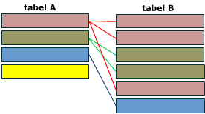

Primary key of table A as foreign key of table B.

Many to Many relationship:
In many to many relations an associative entity is used. The associative entity has the primary keys of both the other tables.

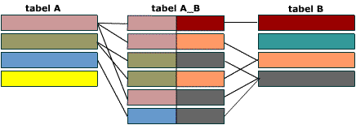

Primary keys of both A and B in table AB.

